

GANDAKI BOARDING SCHOOL
Lamachaur, Pokhara

REPORT ON POSITIVE AND NEGATIVE EFFECTS OF DRUGS

SUBMITTED TO:

SUBMITTED BY:

Aayush Shrestha
Aayushma Gautam
Abhisekh Sapkota
Adhip Pandey
Anu Gairi
Namuna Bastola
Prabesh Thapa
Samyog Shrestha
Sangharsha Kc
Suresh Acharya

RECOMMENDATION

ACKNOWLEDGEMENT

The aforementioned students have carried out study on the topic ‘Positive and negative effects of drugs’. The department of science of Gandaki Boarding School acknowledges the report for the fulfillment of the requirements for report based on secondary education level.

…………………………….
Mr. Bharat Paudel
Department Of Science
Gandaki Boarding School
Lamachaur, Pokhara

……………………………………..
Mr.prameshwor Sharma
Department of science
Gandaki Boarding School
Lamachaur, Pokhara

…………………………………
Mrs. Sakuntala Gurung
HOD, Department of science
Gandaki Boarding School
Lamachaur, Pokhara

EVALUATION

ABSTRACT

A drug is any chemical substance that causes a change in physiology and psychology of an organism when ingested. Drugs are often used to cure, halt, or prevent disease; ease symptoms; or help in the diagnosis of illnesses. Advances in medicines have enabled doctors to cure many diseases and save lives.
Drugs are amazing substances when used as intend but is often misused. This
is often classified as drug abuse. The use of illegal drugs or the use of prescription or over-the-counter drugs for purposes other than those for which they are meant to be used, or in excessive amounts. Drug abuse may lead to social, physical, emotional, and job-related problems.
This report contains a brief introduction on drugs, their classification, types, effects of them in body(both positive and negative) and field data of drugs management and abuse in Nepal.
Drugs are classified on the basis of four criteria: pharmacological effects; drug action; chemical structure; molecular targets. Based on these criteria classification is done. The report also exemplify the most famous drugs of the given category and provides a brief introduction, uses and effects of them.
Research were done from trusted sources references to which are also provided.
Overall, the report highlight the importance of the proper handling of drugs and importance of professional guidelines bringing forth the beneficial as well as the devastating aspects of drugs based on different intake amount and scenarios.

CONTENTS

RECOMMENDATIONS

ACKNOWLEDGMENT

EVALUATION

ABSTRACT

GENERAL INTRODUCTIONS

ANALGESICS

ANTACIDS

ANTIBIOTICS

ANTIHISTAMINES

ANTIPYRETICS

ANTISEPTIC

SULFONAMIDES

TRANQUILIZERS

POSITIVE AND NEGATIVE EFFECTS

HABIT FORMING AND CONTROL

FIELD ANALYSIS

REFERENCES
GENERAL INTRODUCTIONS

INTRODUCTIONS:

A drug is any substance (except for food and water) which when taken into the body, changes the function either physically or psychologically.
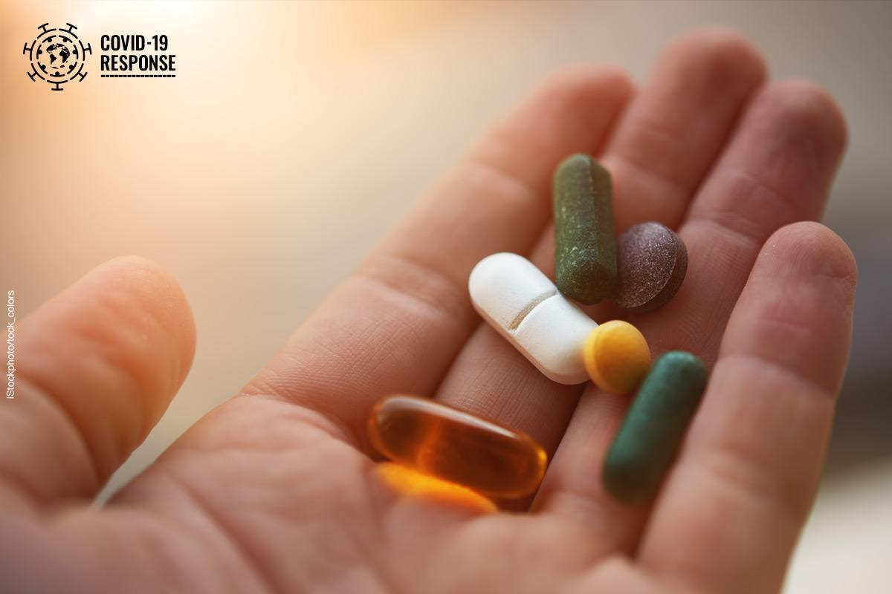
The first modern pharmaceutical medicine was invented in 1804 by Friedrich Sertürner; a German scientist, however the foundation of modern medicine was laid by a Greek physician Hippocrates (450 BC).

( Friedrich Sertürner extracted the main active chemical from opium in his laboratory and named it morphine, after the Greek god of sleep.)

CHARACTERISTICS OF DRUGS

How do you know when a substance is drug? Mentioned below are some characteristics of drugs which explains us the general characteristics of drugs
- Essential medicines are those that satisfy the priority health care needs of the population.
- Essential medicines are selected with due regard to disease prevalence and public health relevance, evidence of clinical efficacy and safety, and comparative costs and cost-effectiveness.
- Drug-like properties, such as solubility, permeability, metabolic stability and transporter effects are of critical importance for the success of drug candidates. They affect oral bio availability, metabolism, clearance, toxicity, as well as in- vitro pharmacology.
NATURAL AND SYNTHETIC DRUGS

Natural chemicals are produced by nature without any human intervention. Synthetic chemicals are made by humans using methods different from those natural formation, and those chemical structures may or may not pre-exist in nature.
Natural drugs are the substances extracted from plants and animals. Examples of them include marijuana, heroin, opium, cocaine and hallucinogenic mushrooms. Synthetic drugs differ from organic ones in that they are produced via chemical synthesis Synthetic drugs are designed to mimic organic botanical compounds, but they often contain highly processed chemicals. The body has difficulty recognizing synthetic drugs, which makes them harder to process and metabolize. For this reason, these drugs are more likely to induce toxicity and adverse side effects, Common examples of synthetic drugs include prescription drugs, crack-cocaine, methamphetamine, etc.

CLASSIFICATION OF DRUGS

From a chemistry point of view, there is no difference between drugs and medicines. All drugs are medicines and all medicines are drugs. A medicine is a chemical substance which is used for the treatment of diseases, reducing different types of pains, has negligible toxicity and does not cause addiction. A drug is a chemical substance which also cures diseases but is habit forming, has serious side effects and causes addiction. Penicillin is an antibacterial agent whereas heroin is a pain killer. Penicillin is a medicine because it does not make the patient addict while heroin is a drug because it is habit forming and has addictive properties.
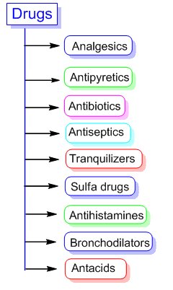

Drugs may be classified on the basis of the following four criteria;

(a) On the basis of pharmacological effect: This classification is based on pharmacological effect of the drugs. A number of drugs are available to cure a particular disease or ailment. Pharmacological effect is useful for doctors because it provides them the whole range of drugs for the treatment of a particular type of disease or ailment.
(b) On the basis of drug action: The classification is based on the action of a drug on a particular biochemical process. For example, the compound histamine causes inflammation and all energy in the body. All antihistamines inhibit the action of histamines.
C) On the basis of chemical structure: it has been found that in many eases, drugs haying common structural features have similar pharmacological activity. Therefore, drugs have at been classified on the basis their of chemical structure. For example, sulfonamides have common structural features and they are mostly antibacterial.
(D) On the basis of molecular targets: Drugs usually interact with the bio-molecules such as carbohydrates, lipids, proteins and nucleic acids. These are also called target molecules or drug targets. Other targets are various enzymes and receptors present in the cell.

ANALGESICS

Analgesics, also called painkillers, are medications that relieve different types of pain — from headaches to injuries to arthritis. Anti-inflammatory analgesics reduce inflammation, and opioid analgesics change the way the brain perceives pain. Some analgesics can be bought over the counter, others require a prescription.

John W. Hughes and Hans W. Kosterlitz at the University of Aberdeen in Scotland discovered analgesics.

What are analgesics used for?
Analgesics are used to relieve pain and inflammation. For example:
• After surgery.
• Due to injury, such as a fractured bone.
• For aches and pains like menstrual cramps or muscle soreness.
• For chronic painful conditions such as arthritis, cancer or back pain.

ANTACIDS

Antacids are a class of medicines that neutralize acid in the stomach. They contain ingredients such as aluminum, calcium, magnesium, or sodium bicarbonate which act as bases (alkalis) to counteract stomach acid and make its pH more neutral. Normal gastric acid pH is in the range 1.5-3.5.

What are antacids used for?
Antacids are used to relieve the symptoms of Gastroesophageal Reflux Disease (GERD also called acid reflux), heartburn or indigestion (also called dyspepsia ). By neutralizing stomach acid, antacids relieve symptoms such as burning in the chest or throat area caused by acid, reflux a bitter taste in the mouth, a persistent dry cough, pain when lying down, and regurgitation.
Some antacids are also used for completely unrelated medical conditions, for example:
- Aluminum antacids: lower elevated blood phosphate levels and prevent the formation of kidney stones
- Calcium carbonate antacids: treat calcium deficiency
- Magnesium oxide antacids: treat magnesium deficiency.

ANTIBIOTICS

Antibiotics are a common medication that doctors prescribe to fight bacteria. Antibiotics are powerful medicines that fight certain infections and can save lives when used properly. They either stop bacteria from reproducing or destroy them.
The first antibiotic was penicillin. Penicillin-based antibiotics, such as ampicillin, amoxicillin, and penicillin G, are still available to treat a variety of infections and have been around for a long time. Several types of modern antibiotics are available, and they are usually only available with a prescription in most countries.
- Alexander Fleming discovered Penicillin, the first natural antibiotic, in 1929.
- Antibiotics cannot fight viral infections.

Uses:
Antibiotics are ineffective against viruses. A doctor prescribes antibiotics for the treatment of a bacterial infection. It is not effective against viruses. Know whether an infection is bacterial or viral helps to effectively treat it. Viruses cause most upper respiratory tract infections (URTIs), such as the common cold and flu. Antibiotics do not work against these viruses.

ANTIHISTAMINES

When histamine, a chemical created by your immune system, overreacts to an allergen such as pollen and pet dander, it can cause symptoms such as coughing, sneezing and watery eyes. Antihistamines are medications that help with allergies, and also with stomach problems, cold, anxiety and more.
Antihistamines are a class of drugs commonly used to treat symptoms of allergies. These drugs help treat conditions caused by too much histamine, a chemical created by your body’s immune system.

Classification
Antihistamines drugs can be classified into two types according to the H receptor-targeted: -
- H1: They are generally used to treat allergic reactions as well as mast cell-mediated disorders. This category can be further divided into two classes: first-generation H1 antihistamines, which have a central effect and are used as sedatives; and second-generation H1 antihistamine which have a lesser central effect and are used as antiallergic drugs.
Examples: Meclizine, Clemastine, Hydroxyzine, Loratadine, Cetirizine, levocetirizine, azelastine etc.
- H2: They are used for gastric reflux disease as they help in reducing the production of stomach acid by reversibly blocking the H2 histamines receptors in the parietal cells of the gastric mucosa.
Examples: Ranitidine, Cimetidine, Famotidine, etc.

ANTIPYRETICS

An antipyretic is a substance that reduces fever. Antipyretics cause the hypothalamus to override a prostaglandin-induced increase in temperature. The body then works to lower the temperature, which results in a reduction in fever. Most antipyretic medications have other purposes.
In 1899, the Bayer Company launched the modern era of antipyretic therapy with the introduction of aspirin as the world's first commercially available antipyretic drug.

The most common antipyretics are usually ibuprofen and aspirin, which are nonsteroidal anti-inflammatory drugs (NSAIDs) used primarily as analgesics (pain relievers), but which also have antipyretic properties; and paracetamol (acetaminophen), an analgesic with weak anti-inflammatory properties.

Paracetamol
Paracetamol is a well-known antipyretic and analgesic compound available for many years for oral administration since intravenous infusion was hampered by water insolubility. Its pro-drug, namely, pro-paracetamol, was applied for intravenous infusion where an amount of 2g was equally potent to 1 g of paracetamol.
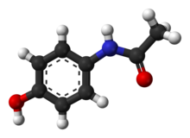
Formula : C₈H₉NO₂
Melting point : 169°C
Boiling point : 420°C
Molar mass : 151.165 g·mol−1
Soluble in : Water, Acetone, Alcohol

ANTISEPTICS

An antiseptic is a substance that stops or slows down the growth of microorganisms. They’re frequently used in hospitals and other medical settings to reduce the risk of infection during surgery and other procedures.

Different types of antiseptics are used in medical settings. These include hand rubs, hand washes, and skin preparations. Some are also available over the counter (OTC) for home use.
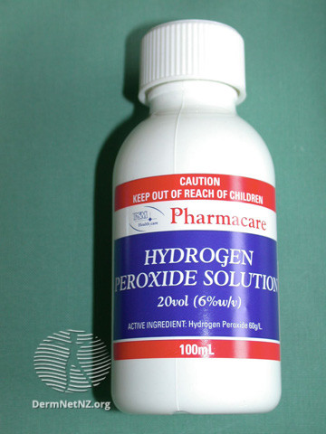
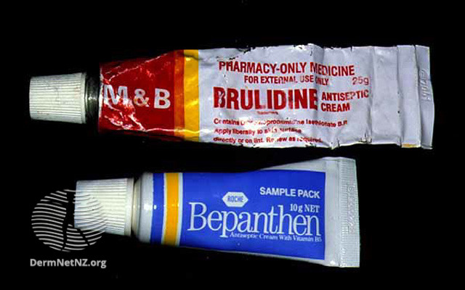

How are antiseptics used?
- Hand washing.
- Disinfecting mucous membranes.
- Cleaning skin before an operation.
- Treating skin infections.
- Treating throat and mouth infections.
What are some types of antiseptic?
- Chlorhexidine and other biguanides. These are used on open wounds and for bladder irrigation.
- Antibacterial dye. These help to treat wounds and burns.
- Peroxide and permanganate. These are often used in antiseptic mouthwashes and on open wounds.
- Halogenated phenol derivative. This is used in medical-grade soaps and cleaning solutions.
SULFONAMIDES

Sulfonamides (sulphonamides) are a group of man-made (synthetic) medicines that contain the sulfonamide chemical group. They may also be called sulfa drugs. Sulfonamide work by interfering with the synthesis of folic acid in bacteria, which is essential for nucleic acid formation and ultimately DNA and RNA. Sulfonamide antimicrobials may be combined with trimethoprim to make them bactericidal (kill bacteria), because trimethoprim acts on a different enzyme in the folic acid synthesis pathway.
Side effects
- Lethargy
- Diarrhea
- Anorexia
- Vomiting
- Photo-sensitivity
- Serious skin rashes

TRANQUILIZERS

A tranquilizer refers to a drug that acts on the CNS and used for the treatment of anxiety, fear, tension, agitation, and disturbances of the mind, specifically to reduce states of anxiety and tension.It also help a person to sleep. A tranquilizer is often called depressants because they supress the CNS and slow down the body.

Tranquilizers induce a well-being sense in a person, thereby releasing him from tension, anxiety, stress, or irritability. They are one of the important components of sleeping pills.

Classification of Tranquilizers

Tranquilizers are available in two variants which are,

- Minor Tranquilizers
- Major Tranquilizers

Minor Tranquilizers also referred to anxiolytics, used for sedation, and to treat anxiety. These drugs are called anti-anxiety medications these days.

Whereas, Major Tranquilizers, also known as neuroleptics or antipsychotics, were developed to treat the disorders of psychiatric, including schizophrenia.

These tranquilizers combat hallucinations and other delusions. Usually prescribed for long terms, the significant Tranquilizers include phenothiazines, butyrophenones, thioxanthenes, rauwolfia alkaloids, and clozapine.

- Sedative
Sedatives work on your central nervous system. They slow down brain activity and can help you feel more relaxed and calm.Common sedatives include barbiturates, benzodiazepines, gamma-hydroxybutyrate (GHB), opioids and sleep inducing drugs such as zolpidem (Ambien) and eszopiclone (Lunesta). Sedatives are central nervous system depressants and vary widely in their potency

Hypnotic
Hypnotics are medications used to induce, extend, or improve the quality of sleep,and to reduce wakefulness during sleep. The most commonly used hypnotics include benzodiazepine receptor agonists (BzRAs), antidepressants, antipsychotics, antihistamines, and melatonin (or melatonin receptor agonists).
Hypnotic drugs also called sleep aids, sleeping pills, or soporifics.

Narcotics
The Narcotic Drug, that produces analgesia (pain relief), narcosis (state of stupor or sleep), and addiction (physical dependence on the drug). In some people narcotics also produce euphoria (a feeling of great elation).
When taken exactly as prescribed by a doctor, for short periods of time, for the relief of severe pain, and under strict monitoring, narcotic analgesics are considered acceptable to use. However, they may still be associated with some severe side effects, despite proper use.
Drowsiness, sleepiness, or dizziness is common with most narcotic analgesics. This can affect driving or a person's ability to operate machinery and perform other hazardous tasks. Some Narcotics include Opium, heroin, Pethidine, etc.

Psychedelic
Psychedelics (also known as hallucinogens) are a class of psychoactive substances that produce changes in perception, mood and cognitive processes.
Psychedelics affect all the senses, altering a person’s thinking, sense of time and emotions. They can also cause a person to hallucinate—seeing or hearing things that do not exist or are distorted.
Some commonly used psychedelics include:
- LSD (d-lysergic acid diethylamide)
- Psilocybin(4-phosphoryloxy-N,N-dimethyltryptamine)
- Peyote
- DMT (Dimethyltryptamine)
- Ayahuasca

POSITIVE AND NEGATIVE ASPECTS

These days many diseases can be effectively alleviated or even cured by taking the appropriate medication. There are drugs available which for example lower blood pressure, reduce blood glucose or treat cancer. The medications you take play an important role in your overall health. However, all medications have side effects, warnings and drug interactions, so it's important to understand your treatments, expected results, and alternative medical options.

Since all drugs can cause side effects, physicians individually way up the expected benefits against the possible risks for every patient. Side effects can vary greatly they range from minor symptoms such as nausea, headaches or skin rashes to more serious side effects like heart rhythm disorders or liver damage. In worst cases, they can even be fatal. It is often impossible to predict whether side effects will occur or not. They can be caused for example, by individual genetic factors. Interactions with other drugs or food stuffs can also trigger side effects.

Some drugs can’t help but trigger side effects because of their chemical structure. The common allergy drug diphenhydramine (also known by the brand name Benadryl) is one. Though it eases allergy symptoms, it also blocks the chemical acetylcholine, and that leads to drowsiness and a host of other side effects, including dry mouth.

Unfortunately, side effects can never be completely ruled out. Fortunately, serious side effects tend to be quite uncommon in most patients. In other words, more people benefit from a drugs than suffer from serious side effects. In any case, patients should be aware of the benefits and potential risks before taking a drug. So, you should always read the information leaflet to find out about possible side effects and ask your doctor or pharmacist whenever needed. When talking to a doctor you shouldn’t forget to mention any other medicines you might be taking. You should also consider whether other diseases have occurred in your family's history and firmly take drugs that have been prescribed for you personally.

HABIT FORMING AND CONTROL

Drug addiction, also called substance use disorder, is a disease that affects a person's brain and behavior and leads to an inability to control the use of a legal or illegal drug or medication. Substances such as alcohol, marijuana and nicotine also are considered drugs. When you're addicted, you may continue using the drug despite the harm it causes.
Drug addiction can start with experimental use of a recreational drug in social situations, and, for some people, the drug use becomes more frequent. For others, particularly with opioids, drug addiction begins with exposure to prescribed medications, or receiving medications from a friend or relative who has been prescribed the medication.
The risk of addiction and how fast you become addicted varies by drug. Some drugs, such as opioid painkillers, have a higher risk and cause addiction more quickly than others.
As time passes, you may need larger doses of the drug to get high. Soon you may need the drug just to feel good. As your drug use increases, you may find that it's increasingly difficult to go without the drug. Attempts to stop drug use may cause intense cravings and make you feel physically ill (withdrawal symptoms).
You may need help from your doctor, family, friends, support groups or an organized treatment program to overcome your drug addiction and stay drug-free.

Symptoms
Drug addiction symptoms or behaviors include, among others:Having intense urges for the drug that block out any other thoughts
- Taking larger amounts of the drug over a longer period of time than you intended
- Making certain that you maintain a supply of the drug
- Spending money on the drug, even though you can't afford it
- Not meeting obligations and work responsibilities, or cutting back on social or recreational activities because of drug use
- Continuing to use the drug, even though you know it's causing problems in your life or causing you physical or psychological harm
- Doing things to get the drug that you normally wouldn't do, such as stealing
- Spending a good deal of time getting the drug, using the drug or recovering from the effects of the drug
- Failing in your attempts to stop using the drug
- Experiencing withdrawal symptoms when you attempt to stop taking the drug

Recognizing unhealthy drug use in family members
Sometimes it's difficult to distinguish normal teenage moodiness or angst from signs of drug use. Possible indications that your teenager or other family member is using drugs include:
- Problems at school or work— frequently missing school or work, a sudden disinterest in school activities or work, or a drop in grades or work performance
- Physical health issues— lack of energy and motivation, weight loss or gain, or red eyes
- Neglected appearance— lack of interest in clothing, grooming or looks
- Changes in behavior— exaggerated efforts to bar family members from entering his or her room or being secretive about where he or she goes with friends; or drastic changes in behavior and in relationships with family and friends
- Money issues— sudden requests for money without a reasonable explanation; or your discovery that money is missing or has been stolen or that items have disappeared from your home, indicating maybe they're being sold to support drug use

Prevention
The best way to prevent an addiction to a drug is not to take the drug at all. If your doctor prescribes a drug with the potential for addiction, use care when taking the drug and follow the instructions provided by your doctor.
Doctors should prescribe these medications at safe doses and amounts and monitor their use so that you're not given too great a dose or for too long a time. If you feel you need to take more than the prescribed dose of a medication, talk to your doctor.

Preventing drug misuse in children and teenagers
Take these steps to help prevent drug misuse in your children and teenagers:
- Communicate: Talk to your children about the risks of drug use and misuse.
- Listen: Be a good listener when your children talk about peer pressure, and be supportive of their efforts to resist it.
- Set a good example: Don't misuse alcohol or addictive drugs. Children of parents who misuse drugs are at greater risk of drug addiction.
- Strengthen the bond: Work on your relationship with your children. A strong, stable bond between you and your child will reduce your child's risk of using or misusing drugs.

Preventing a relapse
Once you've been addicted to a drug, you're at high risk of falling back into a pattern of addiction. If you do start using the drug, it's likely you'll lose control over its use again even if you've had treatment and you haven't used the drug for some time.
- Stick with your treatment plan: Monitor your cravings. It may seem like you've recovered and you don't need to keep taking steps to stay drug-free. But your chances of staying drug-free will be much higher if you continue seeing your therapist or counselor, going to support group meetings and taking prescribed medication.
- Avoid high-risk situations: Don't go back to the neighborhood where you used to get your drugs. And stay away from your old drug crowd.
- Get help immediately if you use the drug again: If you start using the drug again, talk to your doctor, your mental health professional or someone else who can help you right away.

FIELD ANALYSIS

In a developing country like Nepal, accessing unbiased and recent information on medications and therapies is difficult and is still a major limitation. With the closing of certain DICs in Nepal, the smooth functioning of the DICs in Nepal has still not been attained.
The DICs established throughout the country were approached to know the current scenario of the centres. The information was obtained from the authorized personnel of each centre either through telephone or in-person meetings.

The DICs in organizations/hospitals which are fully or partially functioning. DDA, the national drug regulatory authority of Nepal has a provision for the provision of drug information and publication of a drug bulletin as the major departmental activity. In MTH, the DIC is actively involved in the training of Pharmacy students (DPharm, BPharm, and MPharm). However, Drug Bulletin has not been published in the last few years. The DIC of the Institute of Medicine (TUTH), in addition to publishing a bulletin, also handles the pharmacovigilance program, communicates with the international narcotics board and monitors advertisements.
A study in Nepal has shown about 40% of the queries in DIC were regarding ADRs reflecting the importance of DIC in resolving such issues. Also, the role of pharmacists has been identified well in spontaneous ADR reporting, dissemination of medicine information for optimization of drug therapy and better health management of the patients.
The DICs at B.P. Koirala Institute of Health Sciences (BPKIHS), KIST Teaching Hospital, College of Medical Sciences (COMS), and Resource for Primary Health Care (RECPHEC) are not fully functional. In a few other health institutions in Nepal, medicine information providing centers along with Pharmacovigilance (PV) center is in the planning phase designated to work under the Department of Pharmacology or Department of Pharmacy.
Most drugs affect the brain's "reward circuit," causing euphoria as well as flooding it with the chemical messenger dopamine. A properly functioning reward system motivates a person to repeat behaviours needed to thrive, such as eating and spending time with loved ones. Surges of dopamine in the reward circuit cause the reinforcement of pleasurable but unhealthy behaviours like taking drugs, leading people to repeat the behaviour again and again.
As a person continues to use drugs, the brain adapts by reducing the ability of cells in the reward circuit to respond to it. This reduces the high that the person feels compared to the high they felt when first taking the drug—an effect known as tolerance. They might take more of the drug to try and achieve the same high. These brain adaptations often lead to the person becoming less and less able to derive pleasure from other things they once enjoyed, like food, sex, or social activities.
Long-term use also causes changes in other brain chemical systems and circuits as well, affecting functions that include:
• learning
• judgment
• decision-making
• stress
• memory
• behaviour
Despite being aware of these harmful outcomes, many people who use drugs continue to take them, which is the nature of addiction.

• Drug addiction is a chronic disease characterized by drug seeking and use that is compulsive, or difficult to control, despite harmful consequences.
• Brain changes that occur over time with drug use challenge an addicted person’s self-control and interfere with their ability to resist intense urges to take drugs. This is why drug addiction is also a relapsing disease.
• Relapse is the return to drug use after an attempt to stop. Relapse indicates the need for more or different treatment.
• Most drugs affect the brain's reward circuit by flooding it with the chemical messenger dopamine. Surges of dopamine in the reward circuit cause the reinforcement of pleasurable but unhealthy activities, leading people to repeat the behaviour again and again.
• Over time, the brain adjusts to the excess dopamine, which reduces the high that the person feels compared to the high they felt when first taking the drug—an effect known as tolerance. They might take more of the drug, trying to achieve the same dopamine high.
• No single factor can predict whether a person will become addicted to drugs. A combination of genetic, environmental, and developmental factors influences risk for addiction. The more risk factors a person has, the greater the chance that taking drugs can lead to addiction.
• Drug addiction is treatable and can be successfully managed.

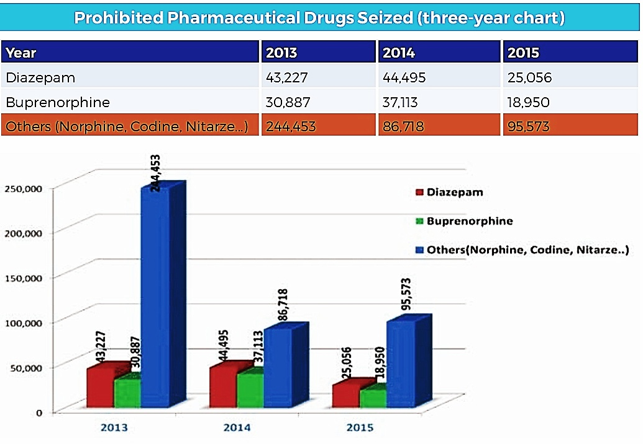
• More good news is that drug use and addiction are preventable. Teachers, parents, and health care providers have crucial roles in educating young people and preventing drug use and addiction.

REFERENCES

Books:

Chemistry Textbook(Grade XII)

Chemistry The Central Science

Applied Chemistry

Internet Sources:

Wikipedia(wikipedia.org)

Drugs Database(drugs.com)

Cleveland Clinic (my.clevelandclinic.org)

Medical News Today (medicalnewstoday.com)

Dermnet NZ (dermentnz.org)

Get Revising (getrevising.co.uk)

Healthfully (healthfully.com)

Pubmed (pubmed.ncbi.nlm.nih.gov)

ResearchGate (researchgate.net)

